APPENDIX 1
KBLR Review of the Lanes planning application Transport Assessment by Vectos.
Planning application 07-2021-00866-ORM and 07-2021-00867-ORM
The Vectos TA is split into two parts in the planning application documents library. In this review the first part of the TA with PDF ref number 226184 is referred to as TA1, and the second part with PDF reference number 226183 is referred to as TA2.
1 Executive Summary.
- The local primary schools in the development catchment are currently under pressure with four of the five schools listed by Vectos at or close to capacity. Committed development demand in the catchment will take any remaining capacity resulting in an effective absence of any primary school places within a two mile radius of the site at the onset of the proposed development. It is estimated that the site will have a population of 523 primary school children.
- Secondary schools in the catchment are also currently under pressure with two of the four listed by Vectos currently exceeding capacity. Of the remaining two with capacity, committed developments will reduce this such that only one secondary school, Penwortham Priory, 3.8 km from site, is likely to have any capacity at the onset of the proposed development. This will severely curtail parent choice in the locality and drive demand further afield. It is estimated the site will have a population of 307 secondary school children.
- No attempt has been made by Vectos to establish the development demographics to understand the levels of demand for local education and health service provision. In addition it appears that no account has been made of the need for formal pre-school facilities, and how this will impact trip demand. It is unlikely that there will be sufficient local pre-school facilities to cater for the demand of up to 493 pre-school children.
- This lack of local Education infrastructure will increase car dependency, and is an illustration of the poor quality of the Vectos transport Assessment background research, especially as a key strand of their proposition is that the numerous local schools “available” in the catchment will reduce car trip demand.
- No account has been made by Vectos in their trip analysis for the provision of 30% affordable/social housing which can have significant impact on demographics and trip demand.
- The committed developments and the proposed development will add over 10,000 people to the local population, with a significant proportion being under 5’s and over 65’s. This will place local GP and health facilities under severe strain. It is estimated that an additional 5 GP’s plus buildings and support staff will be required to provide for this additional population.
- It is unclear if the responsible authorities are aware of the magnitude of the problem facing the region in terms of healthcare and education provision, and what planning has taken place to ensure such essential services are made available into the future..
- Because Vectos have not accounted for population demographics that are specific to new developments of this scale, nor the adequacy of local social infrastructure to support such demographics, their estimation of trip demand and modal split is woefully inadequate.
- Using a trip demand based on likely site demographics it has been found that the Vectos estimation of trips from site has been underestimated by 78% for the am peak and by 61% for the pm peak. This leads to significantly underestimated traffic delays on all local routes and the A582 in particular
- There appears to be systemic errors in the Vectos analysis, for example for all categories of trip eg education, commuting and leisure there is a significant disparity between total arrivals and departures. This is particularly perplexing for education trips where site arrivals and departures by car are 238 and 330 respectively over the standard 12 hour evaluation period, with the implication that approximately 100 children are departing by car in the morning and not returning home after school.
- Other worrying discrepancies can be found in their methodology for model journey time validation shown in the Vectos TA2 tables 17/18 and 19. It has been found that on some of the key routes the observed journey time from Tom Tom data, used to validate model predictive results, does not accord with journey times indicated from Google maps, as significant errors are apparent, with Tom Tom appearing to significantly underestimate journey time at peak hours.
- It has also been found that the Vectos trip rates assigned to committed developments has been underestimated by 30% for the peak hours. This results in a significant underestimation of traffic congestion impacts, making the contribution of the planned development even more severe.
- The estimated two way traffic flow on the A582 from the committed development and the Lanes will add 1,763 two way car trips at the am peak to an observed daily two way am peak traffic flow of 2,125 measured in 2018. The Lanes will be responsible for 888 of these additional two way trips. This is a huge increase in peak traffic flow.
- The committed development and the Lanes will add 11,753 daily average traffic flow to the currently measured (2019) value of 18,872 on the A582. The total daily flow will therefore increase to 30,625. The lanes will be responsible for contributing 5,920 of these additional two way daily trips. Note the LCC congestion reference two way flow for the A582 is 22,000.
- The impact of the trip rate underestimation leads to significantly increased journey times on key routes. In particular for the A582 from the Tank Roundabout to the Penwortham Triangle (Route 1). For example at the am peak Vectos estimate that committed developments will add 6.8 minutes to the journey time, however using more realistic trip rates estimated in this analysis results in a journey time increase of 8.8 minutes.
- For the same route for the scenario of committed developments plus the Lanes Vectos estimate a delay of 8.5 minutes however use of more realistic trip rates estimated in this analysis leads to a journey time increase of 15.1 minutes.
- Similar patterns of journey time increase are observed for the pm peak. Given that under current road conditions Google maps predicts an average peak hour journey time of between 9 and 11 minutes, these predicted journey time increases will be catastrophic for the region.
- It should also be noted that congestion on the B5254 will also be catastrophic as a result of committed development and the Lanes. The data from Vectos TA2 table 7.5 shows that the delays resulting from committed developments will add 12.8 minutes to pm peak journey times, and the addition of the Lanes will increase this to 15.3 minutes. Similar delays are anticipated for the am peak The actual delay is likely to be far higher, as Vectos significantly and consistently underestimate trip demand. It is believed that these delay figures will increase to 17 and 20+ minutes respectively. Such delays will effectively render any bus service using this route non-viable
- Much more concerning is the impact that such delays, along the B5254 corridor and the A582, will have on the AQMA 3 Lostock Hall, AQMA 4 Bamber bridge and the AQMA 1 in Penwortham. The air quality in these locations is some of the worst in the UK. The anticipated increases in traffic volume as a result of committed development and this proposed development, combined with the increased congestion, will significantly worsen air quality leading to higher levels of illness and premature death in the local population. This will increase costs for the NHS.
- Widening the A582 will not provide a solution as it is the numerous major junctions located along the route that determine average traffic speed. Dualling parts of the road will have little impact, and parts of the route subject to the worst congestion are currently dualled with key junctions already upgraded. Providing an additional traffic light controlled junction to access to the Lanes will further weaken the case for A582 widening.
- The A582 widening is also prohibitively expensive (£120+ million) and is likely to provide very poor taxpayer value for money, so DfT funding through the MRN programme appears unlikely. Funding from the Preston City Deal is highly unlikely as the infrastructure programme is in considerable deficit ( minus £100 million) and the poor Governance and financial management of the programme is the subject of a recent complaint to the Local Government Ombudsman.
- The economic impact of the traffic delays on the A582 resulting from the committed development and the Lanes proposal has been quantified and the results are sobering. If the impact of delays on cars and HGV traffic is accounted for, and using Webtag recommended values of time, it is estimated that the committed development delays will cost the local economy £6.89 million per year.
- If the contribution to traffic delays from the Lanes development is added in, then the cost to the local economy rises to £12.39 million per year, with £5.5 million per year directly attributable to the Lanes. This cost penalty swamps any financial benefits listed in the Development supporting statement.
- The delays attributable to the committed developments and the Lanes significantly reduces the average speed on the A582, and therefore fuel efficiency drops. This reduction in fuel efficiency and increase in traffic volume results in additional CO2 emissions and this annual increase in emissions of CO2 can be quantified.
- The CO2 emission resulting from committed development traffic delays is 4,627 tonnes per year. If the delays from the Lanes development is added in this results in an emission of 8,003 tonnes CO2 per year. In 2019 South Ribble produced 243,200 tonnes of CO2 from all transport sources. South Ribble has declared a climate emergency yet committed developments plus the Lanes could add 3.3% to this total.
- It should be noted that delays over the whole local road retwork impacted by this development will generate significantly greater economic cost and CO2 emission levels, with CO2 levels likely to exceed 10,000 tonnes per year.
- If South Ribble plan to offset the 8,003 tonnes additional CO2 emission rate it will need to plant 381,000 trees.
Review report contents Section 1 Executive summary.
Section 2 Introduction.
Section 3 Development demographics, 1100 homes.
Section 4 Schools in the catchment.
Section 5 Health facilities in the catchment.
Section 6 Development Trip assessment and peak demand.
Section 7 Committed development trip assessment and peak demand
Section 8 Impact on the A582,for the 1,100 home development plus committed development.
Section 9 Revised estimates of delay time and economic impact on the A582
Section 10 Traffic delay, impact on CO2 generation A582
Section 11 Conclusions
Section 12 References

2 Introduction.
Following the submission of the two applications to SRBC in July 2021 the supporting Transport Assessment, Appendix 12.1 of the Masterplan has been reviewed. This Appendix is provided in the planning portal as a split document, with the first part referred to as TA1 and the second part referred to as TA2. The Transport Assessment was undertaken by a third party consultant Vectos.
In order to verify the conclusions reached in the TA document an analysis from first principles has been undertaken. All supporting data used in this analysis has been obtained from open source references. In particular a “Population Forecasting Study for New Dwellings” undertaken by Cognisant Research for Northamptonshire Country Council provides extremely useful data. Reference is also made to a report “New Housing
Developments and the Built Environment” commissioned by Cambridgeshire and Peterborough NHS and Cambridgeshire County Council. Both reports provide data on population demographics appropriate for large new housing developments.
The approach in this analysis is to firstly evaluate population demographics likely to arise from the committed developments in the area, and from this specific planning application.
From the resulting demographics a review of the supporting infrastructure was made in particular the availability and capacity of local schools and the provision of GP services.
From an evaluation of demographics the likely trip generation rates are calculated for each sector of the population. Use is made of NTS reports and other surveys to profile the modal split for each sector.
For the purpose of this analysis the distribution of trips throughout the twelve hour analysis period was adopted as for the Vectos analysis.
The impact of this revised trip profile was estimated on the assumption that traffic delay time is directly proportional to trip rate and traffic flow.
The resulting revised delay times and anticipated traffic flows in particular for route 1, which is the A582 from the Tank roundabout to the Penwortham Triangle, have been used to evaluate a traffic delay cost attributable to the dependent developments and the proposed planning application.
Value of time metrics as proposed by Webtag 2014 for the evaluation of road schemes have been employed to monetise resulting delays.
The estimated delays and traffic flows have also been used to calculate CO2 emission rates directly attributable to committed developments and the planning application. Open source literature providing data on vehicle fuel efficiency as a function of vehicle speed has been used in this analysis.
Examination of the Vectos methodology has resulted in some worrying inconsistencies. In particular
- Failure to supply any data on how the various scenarios studied impact on the traffic flow values on the local roads network in particular for the am and pm peak hours.
- Failure to evaluate the development site demographics, leading to gross underestimation of commuting, education and leisure trips.
- When the multi modal trip demand data given in tables 6.5, 6.7, 6.8 and 6.9 of TA1 is summed for the full twelve hour analysis period total arrivals and departures do not align. This is particularly worrying for education trips, given in table 6.8, where over twelve hours there are 330 trips departing from the application site by car (1,100 homes) and only 238 trips returning. For table 6.9 detailing modal split for leisure trips 873 trips arrive on site as a passenger, and 48 depart? This appears to be a systemic error in the model.
- The journey time validation data given in table 17 and 19 for routes 1 and 3 appear to show a significant difference between observed journey times as indicated and derived from TomTom output, and the journey times when observed by Google maps? With the Tom Tom data used by Vectos appearing to significantly underestimate “observed” peak hour journey time when compared with Google maps.
- The assumption made by Vectos that 50% of all leisure trips occur within the planning application site and are therefore not accounted for is not supported nor justified.
- The assumption is made that there are many local schools in the area within walking distance of the site, thus reducing car dependency, yet no attempt is made to establish if any of the local schools will have the capacity to accommodate for the anticipated site demand.
- It is assumed that the local bus corridor along the B5254 will provide a regular and frequent service, thus reducing car dependency . This road corridor is heavily congested at peak periods and new and permitted development in the vicinity will make congestion worse. The reliability of the service is questionable and it is not uncommon for bus services serving Preston to be withdrawn because chronic car dependency and the resulting congestion makes the timetables unreliable. Several examples are given in Reference 1
This analysis has found that the Vectos Transport assessment is deeply flawed and grossly underestimates the adverse impacts of the Lanes development.
3 Development Demographics; 1100 homes
Reference 2 provides data on population demographics as a function of property type and bedroom number. Data is also provided for the demographic impact of social housing. The data set includes a range of new developments built in Northamptonshire.
For the Lanes it is assumed that the property mix is 10% two bedroom, 50% is three bedroom and 40% is four bedroom.
It is stated in the Development Supporting Statement Document paragraph 9.2 that the development has a working age population of 1850 (16+ to 64).
Reference 2 also provides a profile of child age group per dwelling per bedroom number . Table 3.1 Childen by age distribution as a function of bedroom number
Number of bedrooms in dwelling | 1 | 2 | 3 | 4
Pre School Children | 0 | 0.30 | 0.32 | 0.34
Primary School Children | 0 | 0.13 | 0.32 | 0.37
Secondary School Children | 0 | 0.03 | 0.17 | 0.22
Post 16’s | 0 | 0.03 | 0.07 | 0.09

Reference 2 also provides a profile of child age per dwelling per bedroom number for social housing.
Table 3.2 Children by age distribution as a function of bedroom number for social housing
Number of bedrooms in dwelling | 1 | 2 | 3 | 4
Pre School Children | 0 | 0.52 | 0.63 | 0.92
Primary School Children | 0 | 0.19 | 0.83 | 0.58
Secondary School Children | 0 | 0.04 | 0.41 | 1.00
Post 16’s | 0 | 0.05 | 0.19 | 0.58

Assuming the same housing profile as above namely 10, 50 and 40% for 2, 3 and 4 bedrooms, and assuming the development consists of 30 % social housing the number of children and their age profile can be determined.
Firstly the Child profile was calculated for the 70% non-social housing totalling 0.7x1100=770 dwellings.
Table 3.3 Child age group distribution non-social housing
Number of bedrooms in dwelling | 1 | 2 (10%) | 3(50%) | 4(40%) | Total by age group
Pre School Children | 0 | 23 | 123 | 104 | 250
Primary School Children | 0 | 10 | 123 | 114 | 247
Secondary School Children | 0 | 2.3 | 65 | 68 | 135.3
Post 16’s | 0 | 2.3 | 26.5 | 28 | 56.8
Totals by bedroom number | 0 | 38 | 338 | 314

The profile is then calculated for the social housing totalling 0.3 x 1100=330 dwellings Table 3.4 Child age group distribution social housing
Number of bedrooms in dwelling | 1 | 2 (10%) | 3(50%) | 4(40%) | Total by age group
Pre School Children | 0 | 17.2 | 104 | 122 | 243.2
Primary School Children | 0 | 63 | 137 | 76 | 276
Secondary School Children | 0 | 13 | 68 | 132 | 213
Post 16’s | 0 | 17 | 32 | 76 | 125
Totals by bedroom number | 0 | 110 | 341 | 406

It is therefore concluded that the number and age profile for child occupants is as follows
Totals by age grouping
Pre-School = 23+123+104+17+104+122 = 493
Primary School = 10+123+114+63+137+76 = 523
Secondary School = 2.3 +26.5+65+13+68+132 = 307
Post 16’s = 2.3+26.5+28+17+32+76 = 182
Total number of children = 1505
Total number of children excluding post 16’s =1323.
Total number of occupants 0-64 years of age =1323+1850=3173
To establish the population of 65+ age group Reference 3 provides age demographics for a number of new developments in Cambridgeshire. It indicates that the population of 65+ residents is approximately 13% of the development population. This yields a figure of 470 residents over 65, providing the following measure of total population for a 1,100 home development with 30% social housing.
16-64 age =1850
Pre school = 493
Primary School = 523
Secondary School=307
65+ age population =470
Total population estimate = 3,643
For the same development with no social housing the total population reduces to 3,203
For a similar development of 1,350 dwellings and 30% social housing the population increases to
(1350/1100) x 3643 = 4,481
4 Schools in the catchment
The Vectos TA claims that a modal shift in travel will occur as many education facilities are located within walking distance of the development, and a large proportion of education trips will be on foot.
In particular a number of schools were listed as being in the immediate catchment. In table 2.2, page 15, Vectos TA 1 is a list of primary and secondary schools in the catchment.
Considering the primary schools first, the following information has been found by accessing the school websites
Primary School claimed distance from site, pupil numbers and capacity
Table 4.1 Local primary schools distance from site, current pupils and capacity.
 | Pupils | Capacity | Difference
Kingsfold Primary; 1080m | 120 | 210 | 90
Our Lady and St Gerrards, 1190m | 343 | 378 | 35
Penwortham Broad Oak ,1510m | 187 | 210 | 23
Middleforth Primary, 1900m | 208 | 210 | -
Lostock Hall Community Primary, 2400m | 425 | 420 | -
Nominal spare capacity |  |  | 148

Permitted developments in Longton, Hutton, Hoole, Howick and new Longton <1 mile away =127
Permitted developments at the Gas Works and Penwortham Mills <1.5 miles = 633
Permitted developments in Faringdon/Croston Rd/Moss lane ~ 2 miles = 600
Source Vectos TA and Reference 4
Assuming that these permitted developments do not include social housing the primary school demand is anticipated to be (127+633+600)x247/770=436 primary school places.
Unless there is a radical and immediate primary school building programme there appears to be insufficient primary schools to accommodate the permitted development demand. It appears likely that there will be no available primary school capacity for “the Lanes” within a 2 mile radius for the foreseeable future as the Lanes at 1100 dwellings requires 523 primary school places. It is not clear if the responsible authorities are aware of this situation, and what provisions if any have been made. The infrastructure delivery plan does not identify when the two form entry primary will be completed, however the TA assumes places are available when and if the site is extended to 1350 homes.

Table 4.2 Secondary School claimed distance from site, pupil numbers and capacity
 | Pupils | Capacity | Difference
Penwortham Girls High School 2700m | 769 | 744 | -
Lostock Hall Academy 3000m | 612 | 800 | 188
All Hallows Catholic High School 3000m | 900 | 890 | -
Penwortham Priory Academy 3800m | 747 | 1152 | 405
Nominal Spare capacity |  |  | 593

Permitted developments in Longton, Hutton, Hoole, Howick and new Longton <1 mile away =127
Permitted developemts at the Gas Works and Penwortham Mills <1.5 miles = 633
Permitted developments in Faringdon/Croston Rd/Moss lane < 2 miles = 600
Source Vectos TA and Reference 4.
Assuming that these permitted developments do not include social housing the Secondary school demand is anticipated to be (127+633+600)x135/770=238 Secondary School places.
Nominal Secondary School capacity remaining after accounting for permitted developments=355 with a Secondary School place demand from the Lanes of 270 places.
It also appears that parents will effectively have only one “local” Secondary School with any remaining capacity namely Penwortham Priory, this will severely limit parent choice. This may also be a severe constraint to families from some ethnic or faith backgrounds.
Nursery/Pre-School Provision.
It appears that this key educational requirement has not been considered by Vectos in their estimation of Trip generation yet for New Housing developments this is a key consideration. For the Lanes at 1100 dwellings it is estimated that there will be 493 pre-school age resident children.
It is unclear how much local nursery capacity will be available locally for the Lanes development. Reference 5 indicates that 62% of nursery age children are in formal childcare, therefore there is a demand for 306 nursery places within the catchment. It is unclear what if any planning provision has been made for this additional demand.

5 Health facilities in the catchment.
The Lanes development TA mentions one local medical facility at Kingsfold, 1500m from site. For developments containing no social housing the average weighted ratio of occupants to dwelling is 2.78. Reference 2
On this basis in the catchment there are 2367 committed developments with a population of 6580.
The Lanes population will add a further 3643 people to this total, raising the local population to in excess of 10,000. This is materially significant when compared with the current population of South Ribble which is ~110,000.
As this expansion of housing far exceeds the natural population demographics/growth for South Ribble as detailed in the evaluation of the Standard method for housing determination, it appears likely that a significant proportion of this population will be imported from outside of the region, and not displaced from within. This appears to be social engineering on a major scale.
A significant proportion of this population will be under 5’s and over 65’s which will impose a
significant additional demand on local healthcare provision.
The average number of patients per GP has risen to 2087 in 2019 Reference 6. In South Ribble and Chorley in 2013 it was 1712 patients per GP Reference 7. On that basis it is likely that and additional 5+ GP’s and supporting infrastructure including buildings and support staff will be needed to meet the future population demands that result from committed developments and the Lanes. Currently it appears that there is little spare capacity within the local health system to meet existing demand with GP numbers per head of population being lower than the average for England, namely 1315 patients per GP in 2013/14 Reference 8
It is not clear if this additional demand for health care provision is being addressed, nor is it clear that local health care providers are aware of the extent of this developing problem.

6 Development Trip Assessment and peak demand.
6.1 Assessment of Commuting Trips.
The population in the 16-64 age range was reported as 1850 by Taylor Wimpey in the
Supporting Statement. Reference 9 employment statistics for South Ribble April 2020 to March 2021 indicate that 81% of the working age population are economically active.
Therefor it is concluded that 1499 residents in the age group 16-64 are working. The population of 65+ residents is 470.
The percentage of this 65+ age group in work is assumed to be 18%. Reference 9
The number of persons assumed to be working in this group is assumed to be 85.
Therefor the total site population assumed to be in work is 1499 + 85 = 1584 .
Vectos apply a 5% factor to this total to account for home working and inter-site working.(para 6.14 TA 1).
This reduces the working population to 1584 x 0,95 =1505 .It is assumed that each person undertakes a return trip to their place of work eg one departure and one arrival from/to home on site.
To assess the commuting transport mode by car/van Vectos apply a weighted percentage to account for commuting distance. They conclude that 43% of commuting trips are less than 5 km and 57% are >= 5 km . For the shorter commutes they claim 61% of trips are by car and van and for >=5 km the proportion increases to 70%.
It is believed that the Lanes and other similar large developments located close to the SRN are designed to be “dormitory” housing developments, with a significant proportion of residents working outside the South Ribble boundary. As explained previously the committed developments in the region far exceed the local housing demand and that a significant majority originate and work from outside the local boundaries.
This is also inferred by the percentage of commuting trips that depart between 7 and 8 am. This is evidenced in table 6.5, page 46, Vectos TA1 where departures by car are at a maximum between 7-8am with 185 departures compared with 123 departures in the following hour. A typical 5km commute will take 10 minutes.
As a result we have applied a more realistic weighting and assume that 65% of commute trips are >5km.
This results in a weighted percentage trips by car of 0.35 x 61+0.65 x 70 = 67%
Therefore the total number of departure commute trips by car per day =1505 x 0.67= 1008. It is assumed a similar number of arrival trips will also be completed by car per day.
Table 6.5 TA1 was used to establish the proportion of commute departures in the am peak hours 7-8 and 8-9, and arrivals in the pm peak between 16-17 and 17-18.
For the am peak departures a total of 612 trips were accounted for by Vectos over 12 hours with 30.2% departing between 7-8 and 21% departing between 8-9. For the am peak arrivals a total of 545 trips were accounted for with 7.2% arriving between 7-8 and 6.2 arriving between 8-9.
For the pm peak arrivals a total of 545 trips were accounted for by Vectos over 12 hours with
17% arriving between 16-17 and 26% arriving between 17-18. For departures a total of 612 trips were accounted for with 7.8 % departing between 16-17 and 10.3 % departing between 17-18.
In this analysis an equal number of commute departures= 1008 and arrivals= 1008 are assumed over the twelve hour period the peak hour and commute flows are tabulated using the Vectos peak hour proportions above and compared with the Vectos estimated peak flow.
Table 6.1 Commute Trip peak hour analysis from site demographics vs Vectos
Commute am and pm peak period flows using proportions employed by  Vectos table 6.5 | This analysis (% increase relative to Vectos analysis) |  | The Vectos analysis
 | arrive | depart | arrive | depart
7-8 | 73 (+87%) | 304 (+64%) | 39 | 185
8-9 | 62 (+82%) | 212 (+72%) | 34 | 123
16-17 | 171 (+82%) | 78 (+63%) | 94 | 48
17-18 | 262 (+82%) | 104 (+65%) | 144 | 63

It is clear that Vectos have significantly underestimated Commuter trips from the development both for the cumulative twelve hour period and for the peak hours. It is also a concern that for the Vectos drive commute trips the cumulative arrivals and departures do not correlate with 612 departures and 545 arrivals?
Two way peak flows for the am peak between 8-9 indicate that a two way commuting car flow from/to the development of 274 (+75%) will be observed compared with a Vectos value of 157.
For the pm peak between 17-18 it is estimated that two way commuting flows from/to the development of 366 ( +77%) will be observed compared with a Vectos value of 207.
6.2 Assessment of Education Trips
The assessment of trips is made by education category eg Pre-school, Primary and Secondary.
Pre School Trips
Starting with pre-school trip demand, as shown previously, there is estimated to be a pre-school age population of 493 residing at the Lanes.
Reference 5 indicates that 62% of these children will be in formal childcare. This is a
total of 0.62 x 493 =306 children in childcare.
Reference 11 indicates that 73 % of the travel to childcare facilities will be by private vehicle.
Therefore 306 x 0.73 = 223 two way daily car trips required.
Primary School Trips.
It is estimated that there will be a population of 523 primary school age children resident at the Lanes.
Because all the local primary schools will be at full capacity the modal split for travel outside a 1 mile radius will be employed. The split values are given in table 6.6 of the Vectos TA1. This split indicates that 56% of primary school children will travel by car to their place of education.
Therefore 523 x 0.56= 293 two way daily car trips required.
Secondary School Trips.
It is estimated that there will be a population of 307 secondary school children resident at the Lanes.
As all secondary schools are located more than 1 mile away from site it is assumed that 56% will travel to and from their place of education my car.
Therefore 307 x 0.56= 172 two way daily car trips required.
Total Education Trips daily two way.
Pre –school 223
Primary 293
Secondary 172
Total 688
Assume over a twelve hour period 688 departures and 688 arrivals occur.
Table 6.8 Vectos TA1 was used to establish the proportion of commute departures in the am peak hours 7-8 and 8-9, and arrivals in the pm peak between 16-17 and 17-18.
For the am peak departures a total of 330 trips were accounted for by Vectos over 12 hours with 13% departing between 7-8 and 51% departing between 8-9. For the am peak arrivals a total of 237 trips were accounted for with 4% arriving between 7-8 and 19% arriving between 8-9.
For the pm peak arrivals a total of 237 trips were accounted for by Vectos over 12 hours with 10% arriving between 16-17 and 6% arriving between 17-18. For departures a total of 330 trips were accounted for with 4% departing between 16-17 and 2% departing between 1718.
In this analysis an equal number of commute departures= 688 and arrivals= 688 are assumed over the twelve hour period the peak hour commute flows are tabulated using the Vectos peak hour proportions above and compared with the Vectos estimated peak flow.
Table 6.2 Education Trip peak hour analysis from site demographics vs Vectos
Education am and pm peak period flows using proportions employed by  Vectos in table 6.8 | This analysis (% increase  relative to Vectos analysis) |  | The Vectos analysis
 | arrive | depart | arrive | depart
7-8 | 28 (+211%) | 89 (+112%) | 9 | 42
8-9 | 131 (+185%) | 351 (+107%) | 46 | 169
16-17 | 69 (+176%) | 28 (+115%) | 25 | 13
17-18 | 41 (+215%) | 14 (+133%) | 13 | 6

It is clear that Vectos have significantly underestimated Education trips from the development both for the cumulative twelve hour period and for the peak hours. It is also a concern that for the Vectos drive commute trips the cumulative arrivals and departures do not correlate with 330 departures and 238 arrivals?
Two way peak flows for the am peak between 8-9 indicate that a two way commuting car flow from/to the development of 482 (+124%) will be observed compared with a Vectos value of 215.
For the pm peak between 17-18 it is estimated that two way education flows from/to the development of 55 ( +189%) will be observed compared with a Vectos value of 19.
6.3 Assessment of Leisure trips.
Categorisation as Leisure trips is somewhat of a misnomer. Vectos state in para 6.19 TA1
Leisure trips include “ walking the dog, visiting friends, day to day shopping such as for a pint of milk, other shopping, personal business, holiday day trips etc”
The reality is that “Leisure trips” covers all forms of shopping, personal business such as for banking, health visits such as hospital and GP, dentist, post office, religious service, all day trips, holiday trips, visiting friends, trips for entertainment and sport.
Reference 12 indicates that the following leisure trips per person per year are made for the following categories;
All shopping 160
Personal business 60
Visiting friends 75
Day trips 50
Sport and entertainment 30
Total leisure trips (one way?) per person per year 375
Bizarrely Vectos assume that 50 % of such leisure trips will be within the site boundary and are therefore excluded from the calculation. No justification for this assumption is given.
For the purpose of establishing modal split Vectos assumed the same split as for commuting namely, assuming leisure trips >5km ref table 6.4. therefore 70% are by car.
Total trips per day per person= 375/365= 1.03
Assume that the trips are single way trips return trips per person = 0.52
Assume that the trip data relates mainly to the adult population= 1850 (16-64 yrs) +470 (65+ yrs)
Total number of two way leisure trips/day =0.52 x 2320 = 1206
Table 6.9 Vectos TA1 was used to establish the proportion of commute departures in the am peak hours 7-8 and 8-9, and arrivals in the pm peak between 16-17 and 17-18.
For the am peak departures a total of 412 trips were accounted for by Vectos over 12 hours with 6% departing between 7-8 and 9% departing between 8-9. For the am peak arrivals a total of 412 trips were accounted for with 41% arriving between 7-8 and 2% arriving between 8-9.
For the pm peak arrivals a total of 462 trips were accounted for by Vectos over 12 hours with 13% arriving between 16-17 and 14% arriving between 17-18. For departures a total of 412 trips were accounted for with 8% departing between 16-17 and 7% departing between 1718.
In this analysis an equal number of commute departures= 1206 and arrivals= 1206 are assumed over the twelve hour period the peak hour commute flows are tabulated using the Vectos peak hour proportions above and compared with the Vectos estimated peak flow.
Table 6.3 Education Trip peak hour analysis from site demographics vs Vectos
Leisure am and pm peak period flows using proportions employed by Vectos in their table 6.9 TA1 | This analysis (% increase relative to Vectos analysis) |  | The Vectos analysis
 | arrive | depart | arrive | depart
7-8 | 12 (+140%) | 72 (+177%) | 5 | 26
8-9 | 24 (+140%) | 108 (+184%) | 10 | 38
16-17 | 157 (+153 %) | 96 (+200%) | 62 | 32
17-18 | 169 (+156%) | 84 (+190%) | 66 | 29

It is clear that Vectos have significantly underestimated Leisure trips from the development both for the cumulative twelve hour period and for the peak hours. It is also a concern that for the Vectos drive commute trips the cumulative arrivals and departures do not correlate with 412 departures and 462 arrivals?
Two way peak flows for the am peak between 8-9 indicate that a two way commuting car flow from/to the development of 132 (+175%) will be observed compared with a Vectos value of 48.
For the pm peak between 17-18 it is estimated that two way commuting flows from/to the development of 253 ( + 166 %) will be observed compared with a Vectos value of 95.
Bizarrely in the Vectos TA1 table 6.9 under the heading passenger/taxi mode the arrivals over 12 hours total 873 and the departures total 48. There appears to be a systemic error in the way modal trip demand is estimated in the Vectos analysis.
Table 6.4 Total Peak hour car trips by all purposes 1,100 homes The Lanes
 | Total Trip demand summary 1100 homes
Travel hour | Commute |  | Education |  | Leisure |  | Total  1 way |  | Total  2 way | Total  2 way Vectos
 | arr | dept | arr | dept | arr | dept | arr | dept | (difference as  %)
7-8 | 73 | 304 | 28 | 89 | 12 | 72 | 113 | 465 | 578 (+68%) | 345
8-9 | 62 | 212 | 131 | 351 | 24 | 108 | 217 | 671 | 888 (+78%) | 499
16-17 | 171 | 78 | 69 | 28 | 157 | 96 | 397 | 202 | 599 (+61%) | 372
17-18 | 262 | 104 | 41 | 14 | 169 | 84 | 472 | 202 | 674 (+61%) | 418

Table 6.5 Total Peak hour car trips by all purposes 1,350 homes The Lanes
 | Total Trip demand summary 1350 homes
Travel hour | Commute |  | Education |  | Leisure |  | Total  1 way |  | Total  2 way | Total  2 way Vectos
 | arr | dept | arr | dept | arr | dept | arr | dept | (difference as  %)
7-8 | 90 | 372 | 34 | 109 | 15 | 89 | 139 | 570 | 709 (+75%) | 405
8-9 | 76 | 261 | 161 | 432 | 30 | 133 | 267 | 826 | 1093 (+104%) | 536
16-17 | 210 | 96 | 85 | 34 | 193 | 118 | 488 | 248 | 736 (+66%) | 444
17-18 | 322 | 128 | 50 | 17 | 208 | 103 | 580 | 248 | 828 (+63%) | 507

- Committed Development Trip assessment and peak demand.
The committed developments to be considered are given in Table 1 of the Vectos TA2 Table 7.1 Committed developments employed in the Vectos TA
ID | Name | Dwellings | Employment space m2
1 | Croston Road | 174 (350) | N/A
2 | Croston Road North | 400 | N/A
3 | Penwortham Mills | 385 | N/A
4 | Gas Works | 248 (281) | N/A
5 | Cuerden | 210 | 205,600
6 | Test track | 950 | 28,000

7.1 Considering the impact of the dwellings first, assuming no social housing provision.
The provision of social housing mainly impacts the population statistics for children per household. Note if social housing numbers are significant for permitted developemts this caclculation is likely to be an underestimate.
Total committed dwellings =174+400+385+248+210+950 = 2367.
For the lanes at 1100 dwellings and no social housing the population is estimated to be
16-64 age = 1850
Pre school = 357
Primary School = 353
Secondary School = 193
65+ age population = 430
Total population estimate = 3183
For the committed developments it is assumed that similar demographics to the Lanes are valid.
Therefor the trip profile per dwelling is considered to be similar, and the proportion of trips distributed throughout the twelve hour period is also considered similar.
Therefore the committed development population is
16-64 age =1850 x 2367/1100 = 3980
Pre-school =357 x 2367/1100 = 768
Primary school =353 x 2367/1100 = 760
Secondary School = 193 x 2367/1100 = 415
65+ age group = 430 x 2367/1100 = 925
Total population = 6848
The total trip demand for the Lanes at 1100 dwellings is used as the basis for estimated committed development trip profile. The trip profile is then adjusted to reflect the lower demand for education trips as a result of the assumption of zero social housing,and is then scaled in the ratio of the total population of the committed development relative to the total population of the Lanes.
Table 7.2 The Lanes trip demand no social housing.
 | Total Trip demand summary Lanes 1100 Dwellings no social housing
Travel hour | Commute |  | Education |  | Leisure |  | Total  1 way |  | Total  2 way
 | arr | dept | arr | dept | arr | dept | arr | dept
7-8 | 73 | 304 | 19 | 60 | 12 | 72 | 104 | 436 | 540
8-9 | 62 | 212 | 89 | 238 | 24 | 108 | 175 | 558 | 733
16-17 | 171 | 78 | 47 | 19 | 157 | 96 | 375 | 193 | 568
17-18 | 262 | 104 | 28 | 10 | 169 | 84 | 459 | 198 | 657

The trip data above is scaled in the ratio of population, scaling factor =6848/3183 = 2.15 Table 7.3 Committed development trip demand scaled from the Lanes analysis
 | Total Trip demand summary Committed development 2367 dwellings
Travel hour | Commute |  | Education |  | Leisure |  | Total  1 way |  | Total  2 way
 | arr | dept | arr | dept | arr | dept | arr | dept
7-8 | 157 | 654 | 60 | 191 | 26 | 155 | 243 | 1000 | 1243
8-9 | 133 | 456 | 282 | 755 | 52 | 232 | 467 | 1443 | 1910
16-17 | 368 | 168 | 148 | 60 | 157 | 206 | 673 | 434 | 1107
17-18 | 563 | 224 | 88 | 30 | 363 | 181 | 1014 | 435 | 1448

7.2 Consider the impact of commercial floor space on trip demand.
The Cuerden site has planning consent for 205,600 m2 and the test track site has consent for 28,000 m2. The Cuerden site has permission for 210 houses.
To extract the trip rates assigned to the commercial development the Cuerden site trip rate data given in table 5 and 6 of TA2 was employed to extract this data by difference.
To establish the Cuerden trip contribution from housing the total committed development trips tabulated above were scaled down in the ratio of 210/2367 = 0.089.
Table 7.4 Establishing Cuerden commercial trip demand by difference.
Evaluation of commercial site trips using Cuerden data given in table 5+6 of TA2
 | For 210 dwellings scaled  From table above |  | Total trips from Cuerden site  Tables 5+6 |  | Commercial trip contribution by difference
 | arr | dept | arr | dept | arr | dept
7-8 | 21 | 89 | 264 | 221 | 243 | 132
8-9 | 42 | 128 | 648 | 418 | 606 | 290
16-17 | 60 | 39 | 469 | 1467 | 409 | 1428
17-18 | 90 | 39 | 418 | 653 | 328 | 614

The Commercial trip contribution for Cuerden, at 205,600 m2 is scaled down to provide the commercial contribution from the test track development at 28,000 m2.
Table 7.5 Test Track commercial trip demand by scaling from Cuerden.
 | Cuerden Commercial trips for 205,600 m2 |  | Test track site commercial trips for 28,000 m2; factor 0.136 |  | Total Commercial Trips for both sites
Travel hour | arr | dept | arr | dept | arr | dept
7-8 | 243 | 132 | 33 | 18 | 276 | 150
8-9 | 606 | 290 | 82 | 39 | 688 | 329
16-17 | 409 | 1428 | 56 | 194 | 465 | 1622
17-18 | 328 | 614 | 47 | 84 | 375 | 698

8 Impact on the A582, 1100 home development with committed development.
Table 8.1 Summary of total trips for the Lanes plus Committed development.
Total Trips the Lanes 1100 homes plus committed development trips; Local Road Impact
 | The Lanes 1100 homes |  |  | Committed development homes and commercial |  |  | Total trips
 | arr | dept | 2 way | arr | dept | 2 way | arr | dept | 2 way
7-8 | 113 | 465 | 578 | 519 | 1150 | 1669 | 632 | 1615 | 2247
8-9 | 217 | 671 | 888 | 1155 | 1772 | 2927 | 1372 | 2443 | 3615
16-17 | 397 | 202 | 599 | 1138 | 2056 | 3194 | 1535 | 2258 | 3793
17-18 | 472 | 202 | 674 | 1389 | 1133 | 2522 | 1861 | 1335 | 3196

Comparison is now made with the data given in Vectos TA2 tables 5+6 with the data calculated in table 8.1 above.
Table 8.2 Comparison of committed development trips; this analysis vs Vectos
 | Total 2 way trip Generation Committed Development
time | This analysis | Vectos | Factor
7-8 | 1669 | 1198 | 1.39
8-9 | 2927 | 2250 | 1.30
16-17 | 3194 | 3006 | 1.06
17-18 | 2522 | 1844 | 1.37

Vectos TA2 table 7.2 shows the Vectos estimated delays on Route 1 on their network model for North and South bound traffic flows. Route 1 is the A582 between the Tank Roundabout and the Penwortham Triangle.
Scenario 2 is the 2031 base estimated flow plus the committed developments and Scenario 3 is the 2031 base plus committed developments plus the Lanes development at 1100 homes.
It can be seen from Vectos TA2 table 7.2 that the average two way delay (average of north and southbound delays) at the am peak (8-9) for the committed development scenario is 407 seconds, and for the committed development plus the Lanes development at 1100 homes this increases to 510 seconds.
Table 8.2 above shows that Vectos have underestimated the committed development two way flow at the am peak by 30%.
Similarly table 6.4 above shows that the impact of the Lanes development trips at the am peak has been underestimated by 78%.
A similar analysis can be undertaken for the pm peak (17-18)
Assuming that there is a linear relationship between trip numbers and traffic delays which is a conservative position to take, then the estimated delays in the vectos TA1 table 7.2 is revised as follows.
Table 8.3 Revised traffic delays on A582 route 1 to account for Vectos trip demand underestimate.
Revised am peak delays for the A582 (route 1)
 | Scenario 2  2031 base plus CD | Scenario 3  2031 base plus CD plus the Lanes | Difference attributable to the Lanes 1100 homes
Vectos average delay, 2 way | 407 sec (6.8 min) | 510 sec (8.5 min) | 103 sec (1.7 min)
Factor to account for Vectos trip rate underestimation | 1.3 (table 8.2 above) | 1.78 (table 6.4 above)
Revised average delay, 2 way | 529 sec (8.8 min) | 908 sec (15.1 min) | 379 (6.3 min)

Revised pm peak delays for the A582 (route 1)
 | Scenario 2  2031 base plus CD | Scenario 3  2031 base plus CD plus the Lanes | Difference attributable to the Lanes 1100 homes
Vectos average delay, 2 way | 437 sec (7.3 min) | 544 sec (9.1 min) | 107sec (1.8 min)
Factor to account for Vectos trip rate underestimation | 1.37 (table 8.2 above) | 1.61 (table 6.4 above)
Revised average delay, 2 way | 599 sec (10.0 min) | 876 sec (14.6 min) | 277 sec (4.6 min)

These revised delays are significant and economically and environmentally damaging when compared with the current journey time on the A582 from the tank roundabout to the Penwortham Triangle which according to Google maps varies from 7 minutes off peak to typically 10-11 minutes during peak hour traffic flow.
The economic cost to the region will be significant and is calculated in section 9 below.
The delays will significantly increase the emission of CO2 into the environment over the next decades and further reduce air quality in the region. This impact is quantified in section 10 below.
Let us now consider how these trips assigned to the A582. Consider only those developments that are located immediately adjacent to the A582 namely;
- Croston Road Hetherleigh Moss lane 600 homes
- Cuerden 210 homes plus 205,600 m2 commercial floorspace
- Test track 950 homes plus 28,000 commercial floorspace
By scaling the total committed housing development trips in table 7.3 the trip contribution from housing can be found. To this can be added the trip contribution from commercial floorspace to provide the total trips generated from each committed development adjacent to the A582.
Table 8.4 Total trip generation from committed developments adjacent to the A582
 | Croston Road  600 homes |  | Cuerden  210 homes plus 205,600 m2 commercial |  |  |  | Test Track  950 homes plus 28,000 m2 commercial
 | Housing trips |  | Housing trips |  | Commercial  trips |  | Housing trips |  | Commercial  trips
 | arr | dep | arr | dep | arr | dep | arr | dep | arr | dep
7-8 | 61 | 253 | 22 | 90 | 243 | 132 | 97 | 410 | 33 | 18
8-9 | 118 | 365 | 42 | 130 | 606 | 290 | 187 | 379 | 82 | 39
16-17 | 170 | 110 | 61 | 39 | 409 | 1428 | 270 | 174 | 56 | 194
17-18 | 257 | 110 | 91 | 39 | 328 | 614 | 407 | 174 | 47 | 84

In order to assign a suitable proportion these two way flows to the A582 the following broad assumptions were made;
- For the Test Track two way flow 90% reports to Flensburg Way South of the Tank Roundabout. At the tank Roundabout 45% reports to the A582 to/from Preston. The remaining 45% reports to the A582 towards the M6. The balance 10% of two way Test Track trips report to/from Leyland.
- For the Croston Road two way flow it is assumed that 100 % reports to Flensburg Way where at the tank roundabout 50% reports to/from Preston on the A582. The remaining 50% reports to the A582 towards the M6.
- For Cuerden two way flow it is assumed that it is assigned 40% fo/from the direction of the M6, 30% is assigned to/from the A6, and 30% is assigned to/from Preston on the A582.
- For the Lanes trips it is assumed that 100% of the two way trips report to the A582.
On this basis;
The total two way flow on the A582 at the am peak in the vicinity of the Lanes site entrance is therefore;
(1068 (Cuerden) x 0.3) + (697 (Test track) x 0.45) +(483 (Croston Road) x 0.5) + 888 (the Lanes) = 1763 two way trips am peak
To place this flow into context the total observed two way flow measured on the A582 in 2018 in the vicinity of the Lanes site entrance was 2125 two way flows at the am peak.
Reference 13
Therefor the Lanes at 1100 homes plus the committed developments will increase A582 traffic flow by 83% relative to current conditions at the am peak. For 1350 homes the traffic on the A582 will increase by 93% relative to current conditions at the am peak.
The anticipated increase in flow is likely to produce catastrophic traffic congestion on the A582 and surrounding local roads
A582 Dualling will not solve the problem..
The option of dualling the A582 will have little impact on delays as it is obvious that the traffic flow rate on the A582 is primarily determined by the number of closely located traffic junctions. Adding in another traffic light controlled junction between Pope lane and Chainhouse lane to serve the Lanes development will make widening an even more futile and expensive exercise.
It is also clear that there appears to be no source of funding to complete the A582 widening.
Because the project requires extensive bridge works it is likely that the project will cost in excess of £120 million with the Preston City Deal providing £70 million and the DfT providing £50 million. The DfT funding is uncertain as the scheme is likely to demonstrate poor Taxpayer value for Money.
The problem for the Preston City deal is that the finances are in a deficit position, with a current committed deficit of £100 million. Providing a further £70 million to fund the A582 Widening will be considered financially unsustainable.
The poor financial conduct of the Preston City Deal and lack of effective governance is also the subject of a recent complaint to the Local Government Ombudsman which is currently under investigation.
The impact of the A582 junctions on traffic speed is well illustrated in the diagram below which shows recent measured values of traffic speed. This graphic was extracted from the LCC SOBC for the A582 Widening Project Reference 14. The diagram shows the impact on Northbound traffic but the same pattern also exists for the South Bound traffic. Note the classic saw-tooth speed profile, and requirement for multiple acceleration and deceleration cycles. This sawtooth profile generates high levels of pollutants. Also note that the A582 in the vicinity of Stanifield Lane to the M6 is currently dualled and most major junctions have already been upgraded..

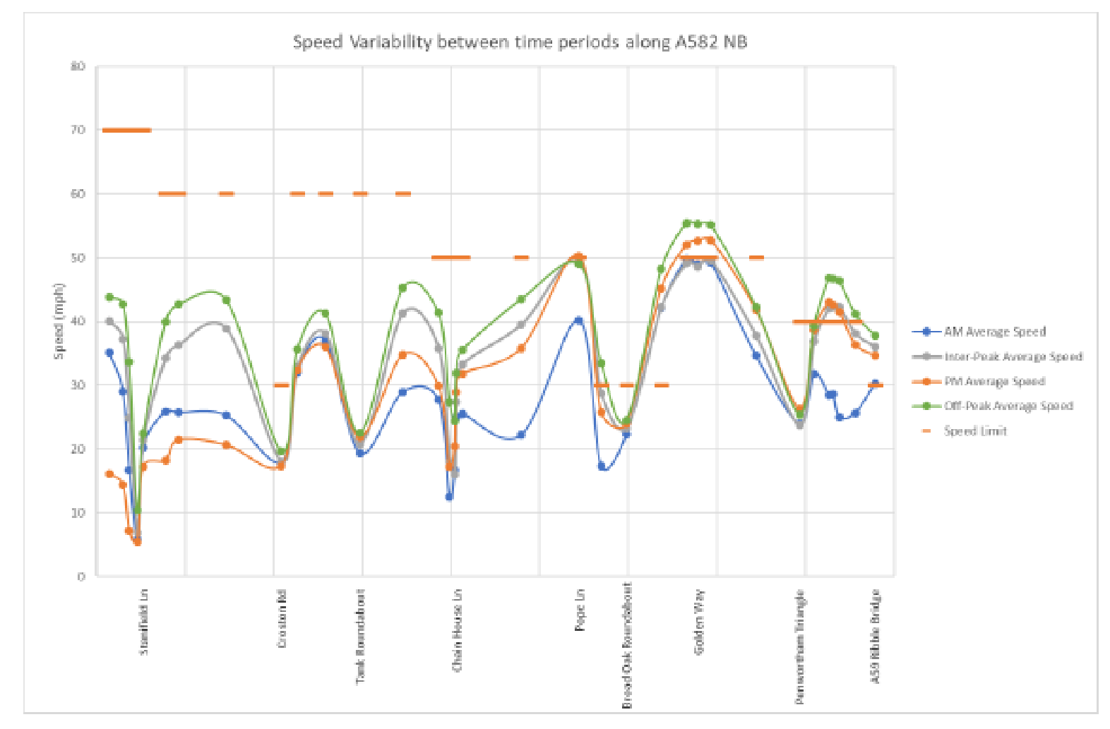
Figure 1 Currently Observed traffic speed variation A582 NB

9 Revised estimation of delay time and economic impact for A582 (route 1).
The following is a calculation to monetise the impact the revised delays identified in table 8.3 will have on the local economy.
From table 6.14 in the Vectos TA1 the percentage of two way flow assigned to each hour in the twelve hour time span is established for the Lanes at 1100 homes.
It is found that that
- 30 % of all two way trips occur between 7.00 and 10.00 am. Assumed average delay 66% of am peak
- 25% of all two way trips occur between 10.00 am and 15.00 pm. Assumed average delay 33% of the pm peak
- 45% of all two way trips occur between 15.00 pm and 19.00 pm. Assumed average delay 90% of the pm peak
Table 3.2 in the SOBC for the A582 Reference 14 provides current traffic data for the A582, compared with congestion reference flows for the road. It shows that the modelled current flow (2020) is 18,872 AADT two way, with a congestion reference flow of 22,000.
If the am peak flow assumed for the committed development and the Lanes at 1100 homes is assumed to be 15 % of the daily total then the total two way flow on the A582 Penwortham Way is estimated to be 1763/0.15 = 11753 + 18872 (2020 base) =30,625 AADT.
Next a weighted delay time is calculated for scenario 2 and 3 for the period 7 am to 7 pm.
For scenario 2 the AADF on the A582 for the 2020 base plus committed development is 24,705.
Table 9.1 Weighted average daily delay time for scenario 2 A582
Scenario 2 Base flow (2020) plus committed development; two way daily flow 24,705
Time period | % flow  split | Flow in time period | Delay in time period (minutes) | Cumulative delay in time period (hours)
7-10 | 30 | 7412 | 8.8 x 0.66 = 5.8 | 7412 x 5.8/60 = 716.5
10-15 | 25 | 6176 | 10.0 x 0.33 = 3.3 | 6176 x 3.3/60 = 339.7
15-19 | 45 | 11117 | 10.0 x 0.9 = 9.0 | 11117 x 9.0/60 = 1667.6
 |  |  |  | Total hours delay per day =2723.80

For scenario 3 the AADF on the A582 for the 2020 base plus committed development plus the Lanes at 1100 homes is 30,625.
Table 9.2 Weighted average daily delay time for scenario 3 A582
Scenario 3 Base flow (2020) plus committed development; two way daily flow 30,625
Time period | % flow  split | Flow in time period | Delay in time period (minutes) | Cumulative delay in time period (hours)
7-10 | 30 | 9188 | 15.1 x 0.66 = 9.97 | 9188 x 9.97/60 = 1526.74
10-15 | 25 | 7656 | 14.6 x 0.33 = 4.82 | 7656 x 4.82/60 = 615.03
15-19 | 45 | 13781 | 14.6 x 0.9 = 13.14 | 13781 x 13.14/60 =  3018.03
 |  |  |  | Total hours delay per day =5159.80

Reference 15 provides Webtag 2014 value of time data employed in road scheme economic appraisal.
The rates are as follows;
- Commuting £7.62 / hour
- Business £24.43 / hour
- Non work travel £ 6.77 / hour
From NTS 2020 the approximate split for car travel trips by purpose is as follows;
- Commuting 15%
- Business 3%
- Non work related 82%
Thus a weighted value of time of £7.43 per hour is applied to the delays given in table 9.1 and 9.2 above.
It is also assumed that the delays estimated above apply mainly to working days, and it is assumed that there are 256 working days in the year in England.
Therefore the cost of delays to the local economy in 2014 prices, just for the A582 Route 1 are as follows;
Scenario 2 ; 2020 base plus committed development = 2723.8 hrs/day x £7.43 per hour x 256 working days per year =£ 5.18 million per year.
Scenario 3; 2020 base plus committed development plus the Lanes at 1100 homes = 5159.8 hrs /day x £7.43 per hour x 256 working days per year = £ 9.81 million per year.
To account for HGV delay costs assume HGV traffic accounts for 10% of the 2020 base flow of 18,872 two way trips per day ref table 7 and 8 of the Vectos TA2, and HGV accounts for 10 % of the commercial trips arising from the committed developments at Cuerden and Test Track, resulting in an additional HGV daily two way trip total of 405 and 55 respectively.
This makes a total of 2347 HGV two way daily trips both for scenario 2 and 3. Assuming that this flow is distributed as for cars and subject to the same delays and a value of time cost of £25.47 / hour, then the cost of HGV delays in scenario 2 is an additional £1.71 million and for scenario 3 an additional £2.58 million.
Therefore A582 Scenario 2 total cost of delays = £5.18 million + £1.71 million = £6.89 million
And the total cost of A582 Scenario 3 delays = £9.81 million + £2.58 million = £12.39 million
Cost to the local economy of travel delays on the A582 attributable to the Lanes development at 1100 houses = £5.5 million per year.

- Traffic delays; Impact on CO2 generation, A582.
The impact of delays on CO2 generation is now calculated by establishing how vehicle fuel efficiency diminishes as a result of delays and reduced average speed. Reference 16 . This shows how car fuel efficiency changes as a function of vehicle speed and engine emissions standard.
Reference 17 also shows how HGV fuel efficiency changes as a function of vehicle speed. For this analysis it is assumed that a mid-weight range HGV namely 12 te rigid is a reasonable average HGV vehicle type.
Using the cumulative delays given in tables 9.1 and 9.2 above for scenario two and three the following CO2 generation rates are calculated for cars.
10.1 Scenario 2 additional CO2 generated from traffic delays.
A582 distance for route 1 is 4.7 km and observed average two way journey time is 347 s or
5.78 min, from Vectos tables 17 and 19 TA2
Therefore the average two way speed is 4.7 x 60 /5.78 = 48.8 km/hr (30.5 mph)
For scenario 2 the cumulative average daily delay time from table 9.1 is 2723.8 hours with an average daily two way vehicle flow of 24,705. Average delay per vehicle is therefore 2723.8 / 24705 =0.11 hr =6.6 min.
Therefore the average speed on route 1, A582 reduces to (4.7 x 60)/ (5.78+6.60) = 22.78 km/hr.
Fuel efficiency for current reported speed condition of 48.8 km/hr = 6 Litres/ 100 km. Reference 16
Fuel efficiency for scenario 2 at an average speed of 22.78 km/hr = 9.3 litres/100 km
Therefore daily fuel consumption current condition = 6/100 x 4.7 x18872 = 5322 litres
Fuel consumption scenario 2 = 9.3/100 x 4.7 x 24705 =10450 litres
Additional fuel cosumption resulting from committed development delays is 10450- 5322 = 5128 litres /day
Assume average density of fuel is 0.8 kg.litre and % w/w carbon in fuel is 87% then
Carbon combusted per day = 5128 x 0.8 x 0.87 =4103.3 kg/day
Assume 100% carbon converted to CO2 and 1 kg mol CO2 weighs 44 kg and 1kg mol carbon weighs 12 kg then CO2 released to the atmosphere = 44/12 x 4103.3 =15044 kg/day
CO2 released per year as a result of committed development delays = 15044 x 256/1000 tonnes per year = 3851.3 tonnes per year.
To account for HGV delays on CO2 emissions assume HGV traffic accounts for 10% of the
2020 base flow of 18,872 two way trips per day ref table 7 and 8 of the Vectos TA2, and
HGV accounts for 10 % of the commercial trips arising from the committed developments at Cuerden and Test Track, and reporting to the A582, this results in an additional HGV daily two way trip total of 405 and 55 respectively, making a total of 2347 HGV two way daily trips both for scenario 2 and 3.
Assuming that this flow is distributed as for cars and subject to the same delays then the the contribution to CO2 generation as a result of delays for scenario 2 is calculated as follows; Current speed on route 1, A582 = 48.8 km/hr. (section 10.1)
Average vehicle delay is 6.6 min and average speed for scenario 2 reduces to 22.78 km/hr.
Reference 17 gives the speed/ fuel efficiency curves for a mid-range rigid 12 tonne HGV.
The HGV total flow for the current condition is assumed to be 10% of 18872 =1887
The fuel consumption at 48.8 km/hr is 16 Litres/100 km.
Therefore average HGV fuel consumption for current road conditions per day = 16/100 x 4.7 x 1887 = 1419 litres.
For scenario 2 the speed reduces to 22.78 km per hour and the fuel efficiency reduces to 23 litres/100 km.
Therefore for scenario 2 HGV two way flow increases to 2347/day and the fuel consumption per day = 23/100 x 4.7 x 2347 = 2537 litres.
Assuming diesel fuel is consumed then the density is 0.85 kg/litre and the % carbon by weight is 87%.
Therefore scenario 2 delays result in an additional 2537- 1419 = 1118 litres being consumed on average by HGV’s.
Using the same calculation method as above for scenario 2 HGV delays add a further 3031 kg CO2 per day or 776 tonnes CO2 per year.
Therefore scenario 2 committed developments delays result in an additional 3851+ 776 = 4627 tonnes/year of CO2 discharged to the environment.
10.2 Scenario 3 additional CO2 generated from traffic delays
Employing the same methodology as for section 10.1 the average delay now increases to 5159.8/ 30625 = 10.11 min from table 9.2 above.
The average vehicle speed reduces to 4.7 x 60 / (5.78 + 10.11) = 17.75 km/hr.
At this speed the fuel efficiency for an average car drops to 10.1 litres / 100 km. Reference 16
Daily fuel consumption for scenario 3 = 10.1/100 x 4.7 x 30625 =14537.7 litres
Daily additional fuel consumption resulting from scenario 3 delays = 14537.7 – 5322 =9215.7 litres.
Equivalent CO2 generation rate = 6921 tonnes /year
Additional contribution from delays experienced by HGV’s;
Mid range HGV fuel consumption at 17.75 km/hr is 27 litres /100 km. Reference 17
Daily fuel consumption = 27/100 x 4.7 x 2347 = 2978 litres.
Therefore scenario 3 delays result in an additional 2978- 1419 = 1559 litres being consumed on average by HGV’s.
This is equivalent to 1082 tonnes per year.
Therefore traffic delays resulting from scenario 3 committed developments plus the Lanes at 1100 homes produce an additional 6921 + 1082 = 8003 tonnes/year of CO2 discharged to the environment.
To put this figure into context South Ribble is estimated to generate 243200 tonnes of CO2 per year from transport in 2019 Reference xx (LCC Carbon Dioxide Emissions report 2019).
Committed developments plus the Lanes will increase this figure by 3.3%
Given that a tree can absorb 21 kg of CO2 per year it will require South Ribble to plant 381,000 trees to offset this additional CO2 generation. This will require approximately 38.1 square km of land.

11 Conclusion.
This analysis shows that the proposed Lanes development will have a major adverse impact on Social infrastructure. It appears that there will be no availability of primary school places from the onset of the development within two miles of the site.
The provision of Secondary School places will be under severe pressure will little or no parental choice in the catchment area.
It is doubtful if there will be sufficient formal pre-school facilities available in the catchment.
This absence of local education infrastructure will lead to increasing levels of car dependency and congestion.
There needs to be a significant investment in GP and medical facilities in the region in order to cater for the significant increase in local population that will result from the committed developments and the proposed Lanes Development. It is not clear if there are plans for such an investment to be made, and the absence of such investment will lead to a significant worsening of the quality of local healthcare provision.
It is not clear that the responsible authorities are aware of the magnitude of the infrastructure problem that will need resolution if the Lanes is permitted. It is not clear that the responsible authorities are fully aware of the impact of the committed developments, especially for the provision of education services.
It appears that Vectos have grossly underestimated the impact of car dependency that will result from the development by a staggering 78 %. The impact of traffic delays on the A582 will be catastrophic.
Although time pressures have limited our analysis to impacts on the A582 it is likely that such underestimates of traffic demand will also severely impact on the other local roads. In particular on the B5254 and the junctions with the SRN.
The economic impact of traffic delays to the region will be severe, with delays on the A582 alone resulting in an economic cost of £5.5 million per year. Note that delays throughout the network will add significantly to this total.
These delays will increase CO2 emissions to the atmosphere as traffic speed slows to a crawl on the A582, at 17.75 km /hr. CO2 emissions resulting from committed developments and the Lanes traffic delays on the A582 will add just over 8000 tonnes/years CO2 to the atmosphere.
If other delays in the local road network are also accounted for it is likely that total CO2 emissions will be in excess of 10,000 tonnes. This is not a good situation for a local council that has declared a climate emergency and has a current CO2 emission total from road transport of 243,000 tonnes per year. Reference 18.

12 References.
- LCC transforming Cities Bid. November 2019.
- Population Forecasting Study; Cognisant research for Northamptonshire County Council 2014.
- New Housing Developments and the Built Environment; Cambridgeshire and
Peterborough Clinical Commissioning Group and Cambridgeshire County Council. 2017
- SRBC Housing Position Statement April 2020.
- Childcare and Early Years Survey of Parents in England 2018 for the DfE.
- Article in Pulse magazine July 2019
- Lancashire Pharmaceutical needs Statement 2015
- Lginform Website-Ratio of GP’s per 10,000 population in England .
- Nomisweb employment statistics for South Ribble.
- Employment Statistics for Workers age 50 and over, by five year age bands and gender for DfW and P Nov 2015.
- Exploring travel behaviour in households with pre-school children. Journal of the transportation research board January 24 2021.
- UK Gov publishing service data file 131460/37-Chart 37 Trips by purpose NTS.
- Croft Edison TA for the 2020 Lanes Masterplan
- SOBC LCC A582 Widening Project July 2019 (redacted)
- DfT Technical report; Provision of Market Research for Value of travel Time Savings and Reliability 15 August 2015. Arup.
- Reduced Carbon and Energy Footprint in Highways Operations; The Highway Energy Assessment (HERA) Methodology.
- Speed Emission/Energy curves for ultra-low emission vehicles. Ricardo AEA for the DfT 23 June 2015.
- LCC document Carbon Emissions Summary 2019 Table 1; local and regional estimates for CO2 emissions

APPENDIX 2

KBLR response to the Masterplan Flood Risk and Drainage Strategy and Appendix
11.1 Lee Roxborough and McCloy Flood Risk Assessment
Executive Summary

- The Flooding assessment Appendix 11.1 fails to state what the uncontrolled surface water runoff will be for the development. This information is essential to set a design baseline.(para 1.2)
- By making reasonable assessment of impervious surfaces it is estimated that the post development run off from catchment A will be 4034 m3/hr and from catchment B 4076 m3/hr. (para 1.3, 1.4)
- In order to control this excessive run off rate the developer proposes a large flow controlled gravity draining attenuation basin to the west of the site for catchment A, and a large flood basin with flow controlled pumped outflow to the North of the site for catchment B.(para 2.1, 2.2, 2.3, 2.4, 2.5)
- For catchment A the developer proposes that the new dwellings will have raised foundations with a minimum height of 0.15 m, however, tellingly the developer remains silent on the maximum height of foundations. Because of the need to dispose of 40,000 cubic metres of excavation spoil from the attenuation basin and associated swales it is almost certain that large areas of the site will be raised to the detriment of existing dwellings. (para 2.3).
- For existing dwellings at ground level this proposal will considerably increase flood risk relative to those with raised foundations.(para 2.3)
- The developer states that property in catchment A will be protected up to a 1 in 30 year rainfall event. For structures designed for a 60 year life those structures will on average experience two flooding events in that time. Data produced by the Met office states that the probability of 1 in 30 flooding event has increased for all regions of the UK during winter and for Dorset and the North West of England in particular for summer periods, so it is highly likely that these properties will experience more than two flooding events on average in 60 years. (para 2.3)
- The catchment B flood basin is designed with significantly raised earthworks on the southern side of the basin. Again the developer states a minimum height of 0.63 m above the 1 in 100 year flood level. Note again no maximum is quoted and that the height is not relative to a ground level datum but to a flood level. It is quite possible that the earthwork berm could be 1-2 m in height. Note that this raised earthwork structure completely or partially surrounds a number of existing properties. Those properties will be at significantly increased risk of flooding and the environmental and visual impact will be severe. (para 2.6, 2.7,2.8)
- A graphic is provided in Appendix 11.1 that shows in a 1 in 100 flooding event plus a 40% global warming allowance the flood basin has insufficient capacity and it preferentially floods Kingsfold which is unprotected because of the absence of protective earthworks on the north side of the flood basin. Indeed it appears that the raised earthworks to the South of the flood basin are designed to protect the site to the South whilst sacrificing Kingsfold to the North. (para 2.8, 2.15)
- The flood basin has a capacity of 16,205 cubic metres. At a run off rate of 4076 cubic metres per hour the basin will flood in just under four hours. It is suspected that this is the reason no post development run off rates are provided in any of the documents as this capacity appears inadequate. The pumps are limited to a rate of 100 litres/sec so they will have little impact on this flooding time. It is reported in a Defra/Environment Agency paper “Extreme Rainfall and Flood Event Recognition” Aug 2002 that for the majority of extreme rainfall events measured from 1930 to 2000, the duration ranged from 3-60 hours with the average ~20 hours. This data indicates that the flood basin design will be ineffective for the majority of extreme rainfall events as it has insufficient capacity. (para 2.13, 2.14)
- The use of a pumped outflow from the flood basin provides another system vulnerability and is likely to be in continuous use to maintain a drained basin in the event that an extreme rainfall event should occur. If these pumps are electrically driven the electrical supply also needs flood protection, and no mention of this is made in the report. Indeed the Welsh Government states that for groundwater drainage solutions “because of the ongoing energy and maintenance requirements of pumping water and the risks associated with failure pumping should be avoided where possible” (para 2.9,2.10).Certainly the use of a pumped discharge system is not sustainable.
- There is no assessment, in any of the Flooding documentation, of the impact of system failure either through poor design or maintenance. Indeed it unclear who will be responsible for the costs of system failure should this occur. The lack of clear accountability for system failure resonates with the situation apparent for the Grenfell Tower tragedy, with multiple design authorities involved but no clear accountability. (para 2.11 and section 4)
- There appears to be significant shortcomings regarding the hydrological model employed in the flood predictions. In the section of the appendix dealing with model validation the authors claim that the pictures of extreme flooding posted on the internet by scheme objectors represent a historic 1 in 30 year rainfall event and the model accurately predicts the extent of flooding observed in the photographs. Any local resident will point out that the flooding observed in the photographs occurs regularly and is not a 1 in 30 year event. This then raises serious questions regarding the integrity of the model and its ability to predict current regular flooding and a true 1 in 30 year event. (para
3.1, 3.2)
- The authors also state “No detailed flood data is available for accurate validation or calibration of the model” yet this proposal has been promoted by developers since 2015. It is therefore remarkable that in the intervening period no attempt has been made to collect this critical data. (para 3.2)
- Spoil disposal from the excavation of the attenuation basin and swale system to the west of the site will generate approximately 40,000 tonnes of waste boulder clay, requiring the equivalent of approximately 2,000 truck trips. This has the potential to generate a significant emission and transport problem. It is unclear how the developers propose to manage this spoil generation.
(section 5)
- The utility company responsible for sewage treatment in the region is United Utilities. This company has a shocking record of underinvestment and routine discharge of untreated sewage to river and sea, indeed it has the worst record in England. This is symptomatic of a local sewage treatment infrastructure that is not fit for purpose. On this basis alone no new housing development applications should be approved in South Ribble until United Utilities can guarantee that routine discharges of untreated sewage to river and sea have been halted. Approving this application is almost certain to increase the frequency and duration of such discharges. This is totally unacceptable as it is maximising shareholder profit at the expense of our environment. (Section 6).

Setting the baseline
  - Existing run off rates for the two main site catchment areas for the site, catchment A and catchment B are estimated by employing data from Figure 4.1 and Figure 4.4 and table 4.2, 4.3 and 4.4. Figures 4.1 and 4.4 are overlaid to provide a surface area weighted existing run off rate. Data for the 1 in 100 year rainfall event plus 40% global warming contingency is used.
  - Catchment B, 23.1 Ha total area, is covered entirely by existing catchment 3 and therefore has a total existing runoff rate of 23.1/54.5 x1335 litres/sec = 566 litres/sec = 2038 m3/hr.
  - Catchment A , 54 Ha total area, area consists of approximately 50% existing in catchment 3, 30% in catchment 2 and 10% in catchment 1 giving a weighted run off rate of ((0.5 x1335)+(0.3 x376.5)+( 0.1 x 184.3)) x 54/77.4 = 560 litres/sec = 2017 m3/hr
  - Appendix 11.1 states “Uncontrolled flows from the development will exceed existing run off rates” but the report fails to state what they would be.
  - Data from a drainage strategy paper for a site off Blackburn Road Longridge indicates that for a site of this nature with a total development area of 30,000 m2 , buildings occupy 10,090 m2 and roads footpaths and parking occupy 12,310 m2. Therefore the percentage impervious surface is 22,400/30,000 = 75%. Leaving a permeable surface for run off attenuation equivalent to 25% of the development area.
  - Taking a position assuming 50% permeable land remains for both catchments post development, the development run off flow is likely to be at least double the existing run off flow, which for catchment A is 2017/0.5 m3/hr or 4034 m3 per hour and catchment B is 2038/0.5 m3/hr or 4076 tonnes per hour. This is fundamental baseline information which was excluded from Appendix 11.1.
  - The site is essentially landlocked with only one watercourse available for drainage namely Mill Brook.
  - Mill Brook also serves to drain surface water from existing developments in Kingsfold and Penwortham and from the surface of the A582 and the Penwortham Bypass and from existing properties on site. There has been no attempt to calculate the run off flows from these existing sources for the I in 100 year design scenario above, and whether Mill Brook is capable of functioning under such circumstances and what the water levels are likely to be.
  - The developers recognise that site run off needs to be controlled.

- The proposed solution.
  - The developers propose the use of two outflows from site both draining to Mill
Brook. One is to the North of Kingsfold using the Northern Tributary Boundary Culvert (Outfall 3). The second is to the South of Kingsfold where a drainage culvert crosses Penwortham Way (Outfall 2).
  - These outfalls will serve two drainage catchment areas A and B. Catchment B is the area of site that has the seriously challenging flooding risk and drainage conditions and will be drained to Mill Brook via Outfall 3 (Northern Culvert). Catchment A is 54 Ha and existing drainage is 560 litres/sec for the 100 year plus 40% event. It is proposed to drain this via Outfall 2. Catchment B is 23.1 Ha and has a drainage rate estimated at 566 litres/sec for the 100 year plus 40% event. Because of the site topography and geology both catchments face considerable flooding risk. The diagrams below show catchment details.
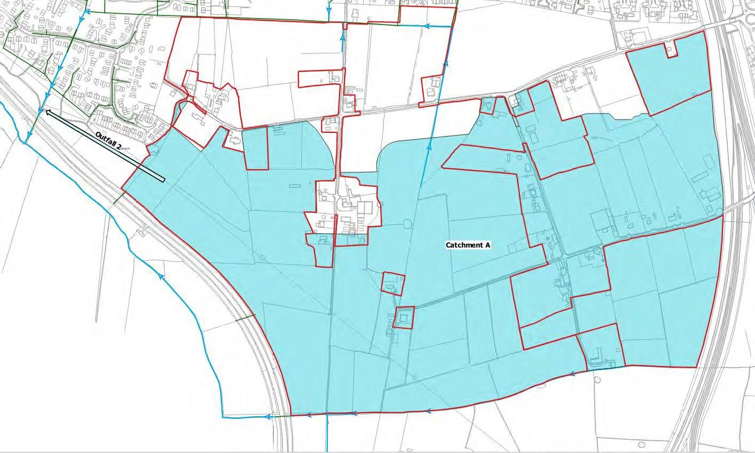
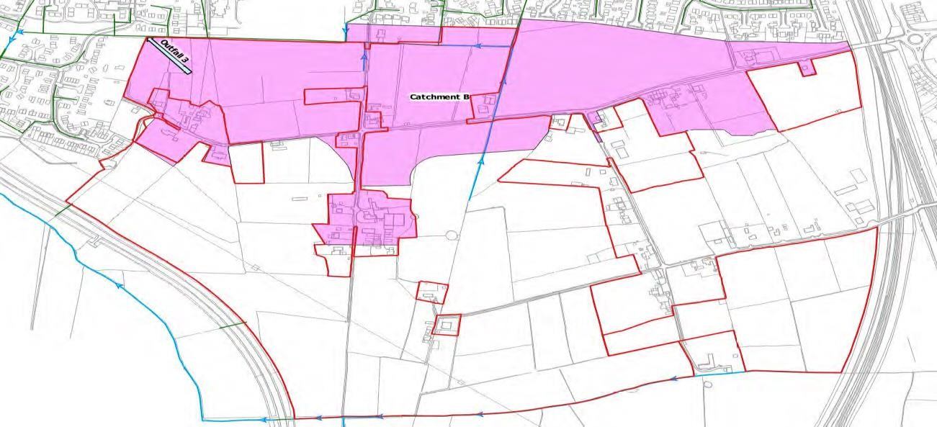

  - The proposed flood mitigation solution for catchment A is a large attenuation basin with an interconnected swale system. The development floor levels will be set to a minimum of 0.15 m above the ground level. The lack of any information on the likely maximum foundation elevation indicates extreme design uncertainty. In some areas it is likely that foundations could be raised to 0.5 m. Houses and hard surfaces will have piped surface drainage systems that will prevent flooding up to a 1 in 30 year event. That equates to a yearly probability of such an event occurring as 3.33 %. As these houses will be built to exist for a minimum of 60 years each property in this catchment is likely to experience on average two flooding events over sixty years. The probability of flooding for existing properties in this catchment without raised foundations is likely to be far higher. It is also noted that these “thirty year” events are becoming far more frequent as indicated in the met office report to Ofwat dated July 2010.It states all winter rainfall events for all areas of the UK are predicted to become more frequent, and that for the 20, 30 ,50 and 100 year events the biggest summer increases are projected to occur over both Dorset and North-West England
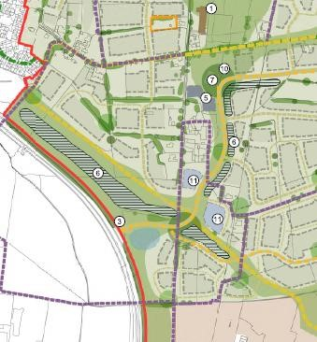
Catchment A attenuation ponds and swale system shown as feature 6.

  - The outflow from the catchment A attenuation basin is controlled to 100 litres/sec using a hydrobrake. These structures are vulnerable to silting and require regular maintenance. The reason for the outflow restriction is to prevent excessive demand on the outfall to Mill Brook. It is estimated that the attenuation basin has a surface area of approximately 600 x 25 m. Assuming it will be 2 m deep approximately 30,000 cubic metres of clay spoil will need to be disposed of either
on or off site. Assuming the catchment A attenuation basin capacity is 30,000 cubic metres will take approximately 7.5 hours to fill. This appears insufficient given the likely duration of the 1 in 100 year rainfall event, please refer to para 2.13 below. The total spoil resulting from the excavation of the attenuation basin and the swales is over 40,000 cubic metres. If disposed of on site the implication is that significant areas of the site will be raised with an increased flood risk for the existing dwellings in the vicinity. Vague references are made in the documentation to the need to raise parts of the site but no specific values are given.
  - The proposed flood mitigation for catchment B is far more complex because of the site topography and drainage catchment area. It is concluded in the appendix 11.1 that there is insufficient gradient for gravitational flow from an attenuation basin as for catchment A. The approach proposed is to create an artificial flood basin at the north boundary of the site shown as feature 4 on the Illustrative Master Plan. The scheme is also shown in figure 4.12 of Appendix 11.1 and on
McCloy drawing titled “Proposed Daylighting and Reprofiling” Fig No M01852-01.
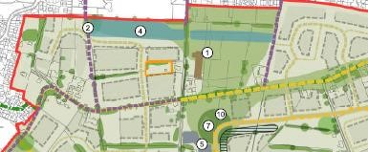
The flood basin as shown on the Illustrative Master Plan (marked as feature 4)
  - The drawing shows a flood basin with a capacity of 16,205 m3 Appendix 11.1 table 4.5. The estimated area of the flood basin is 400 x 20m .What is concerning is that water is channelled into the flood basin by employing raised earthworks to the south of the flood basin which are raised to a minimum level of 0.63 m above the predicted 100 year event water level. Ref page 40 of appendix 11.1. It is noted that no earthworks maximum height is given again demonstrating extreme design uncertainty. This statement leaves the developers with the freedom to raise earthworks significantly higher eg 1m+, with significant environmental detriment to the existing properties. This does not appear a credible solution given the impact the earthworks will have on existing property owners..
  - This artificial earth “berm” is not shown on the masterplan illustration. However a number of existing properties at the North end of the site are shown in the referenced McCloy drawing at the back of Appendix 11.1 partially or completely surrounded by raised earthworks. This is a wholly unacceptable proposal. The authors of the report only state a minimum elevation. The actual height of these earthworks could be far higher (1 m+). This will place these properties at significantly elevated risk of flooding and will adversely impact visual amenity.
  - The proposed arrangement is shown below extracted from the McCloy drawing.

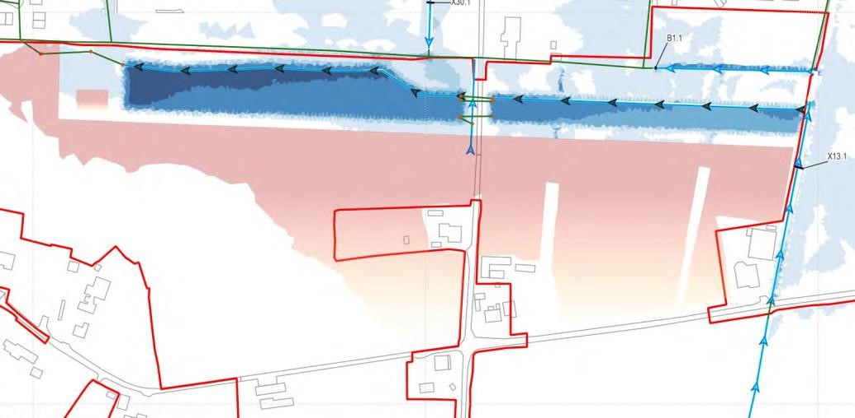
Catchment B Flood Basin. The area shown in red is the raised earthworks. Note the existing properties that are totally or partially surrounded by the raised earthworks.
  - The design of the flood basin is such that it cannot gravity drain to Mill Brook via the Northern Culvert. What is proposed is a flow controlled pumping station. There is very little design information on the pumping station other than it will incorporate a duty and standby pump. If electrically powered it is critical that the sub-station providing the power is also flood protected. This requirement is not mentioned in the Masterplan documents.The Welsh Government Standard for the design construction and operation of surface water drainage systems 2018 states wrt pumped systems “Because of the ongoing energy and maintenance requirements of pumping water and the risks associated with failure, pumping should be avoided where possible”
  - The standard also states “Where the drainage system is to be adopted the developer should ensure that the adopting organisation has agreed in principle to adopt the pumping station before putting in the planning application” The appendix 11.1 section 5.5.1 simply states “It is proposed that the main piped system and pumping station will be adopted by United Utilities”. It is not clear if any agreement is in place with United Utilities. Clarification on this matter is the subject of an EIR with united Utilities.
  - There is little evidence in the report of a proper analysis of the economic impact of pump system failure either through poor design or maintenance, and it is unclear who will be financially responsible. The impact of system failure will be profound effecting existing and development properties. The authors simply state there is a very low probability of both duty and standby pumps failing and in any case the capacity of the flood basin is sufficient to absorb all flood water runoff.
The paragraph below demonstrates that this is not true.
  - Assuming the current water runoff rate is 566 litres/sec for catchment B and the area when fully developed will consist of 50% impermeable structures such as houses, roads, parking, and gardens hydraulically isolated by road and housing foundations then the development run off rate for the 100 year event plus 40% global warming allowance is 566/0.5 = 1132 litres/sec = 4075 m3/hr. On this basis the flood basin has sufficient capacity to absorb runoff for 16205/4075 = 4 hours ~240 minutes. This is hardly sufficient as a one in 100 year flooding event is likely to last significantly longer than 4 hours. This capacity also appears insufficient to undertake emergency pump repairs should a common mode fault develop requiring either pump repairs, sump drainage or the installation of a diesel powered pump back up pump. In any case the proposed pumped outflow of 100 litres/sec which is hydrobraked, will have little impact in arresting the impact of predicted runoff water rates.
  - A Defra report published in 2002 “Extreme Rainfall and Flood recognition” provides data on extreme rainfall event durations from the 1930’s to 2000 shown in table 3 of the report. It lists 60 events of which 32 were of duration between 3 and 60 hours with the average being 20 hours. Should durations of this nature occur for the 1 in 100 storm the majority of catchment B would be flooded after a few hours as the flood basin will have insufficient capacity, and as the outfall pumps are constrained by a hydrobrake to 100 litres per second, which appears insufficient to make any impact on draining a flood basin capacity of 16,205,000 litres.
  - Appendix 11.1 section 3.8.1 outlines a “Critical Duration Analysis” which is an attempt to establish the duration of a flooding event (one in thirty and one in one hundred events plus 40% global warming allowance) over which flooding levels are at a maximum. The analysis results in table 3.2 show this to be 360 min (six hours). The authors do not state the duration of the rainfall event which was employed as the basis of this analysis. This result does not appear credible as it appears likely that most extreme rainfall events will occur over a much longer duration than 6 hours. Also after four hours the flood basin protection will have failed rendering this analysis meaningless.
  - It is clear in the appendix 11.1 that the flood basin is designed to protect the site. What may not be apparent to the reader of the Masterplan documents is that the impact of the flood basin design is to considerably increase the risk of flooding to properties in Kingsfold to the north of the flood basin. The diagram below, next page, shows the impact of the proposed flood basin design on Kingsfold. It is unlikely that the residents of Kingsfold or the appropriate authorities are aware of this significantly enhanced flooding risk.
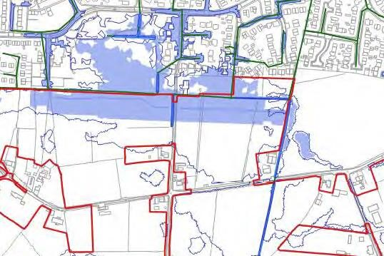
Note this figure given as Fig 4.15 in the Appendix 11.1 shows the flood basin filled and overflowing into Kingsfold in the case of a 1 in 100 year event plus a 40% global warming allowance. Note the raised earthworks to the immediate south of the flood basin “protect” the site at the expense of Kingsfold which has no protective earthworks. Note the diagram does not show the full extent of flooding in Kingsfold; and that the Penwortham Town Council Building appears to be impacted by flooding.
  - Not only has the flood basin been designed to flood Kingsfold in preference to the site it is also proposed to re-direct surface water that originates in Kingsfold and is currently managed via the Northern Culvert, to a more southerly culvert .
Para 6.5 of the Lees Roxborough report Appendix 11.1 states “it is proposed to redirect flows (from Kingsfold) currently entering the system from upstream outfall B (Northern Culvert) to downstream (outfall A) of the existing development (More southerly Culvert under Penwortham way) and hence reducing the volume of water reaching the most vulnerable area of site”. In other words the proposal is to shift the current drainage route from Kingsfold to a more vulnerable upstream position on Mill Brook in order to reduce the volume of flow to the Northern Culvert and hence help protect the site, at the expense of Kingsfold. There is also no mention of how this re-routing is to be achieved and whether the developers have the agreement of all landowners or the Utility company responsible.

- The integrity of the hydrological model.
  - Appendix 11.1 section 3.10 deals with model validation. In this section the authors argue that pictures of “historic” flooding provided by “objectors” to the scheme in fact help validate the model. The authors imply that the two photos in question are from a one off historic event. By comparing the photos with what is predicted in the model they claim the model then accurately predicts such a “historic” event and proves the model is sound.

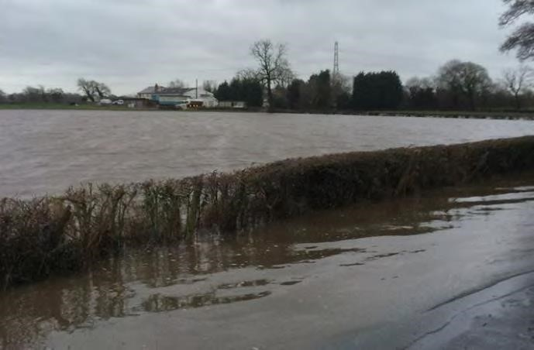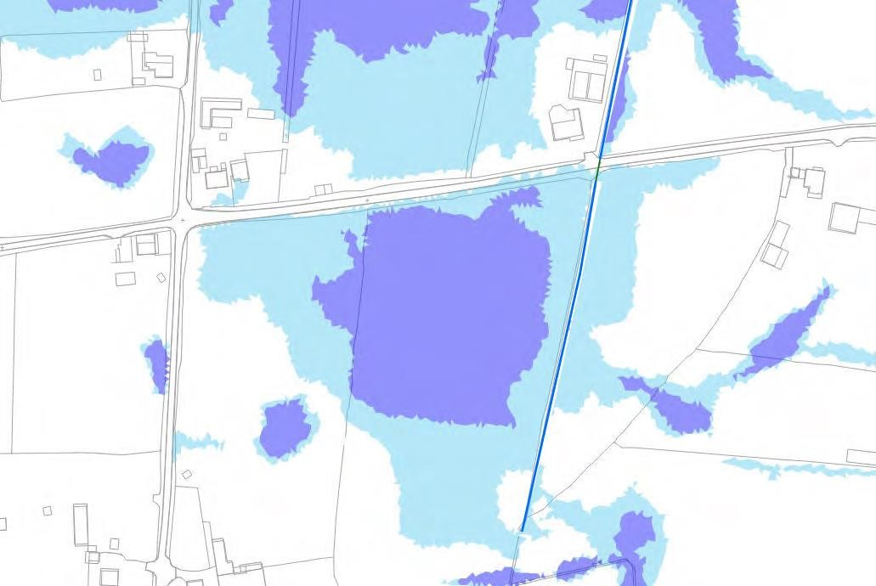
Approximate location and direction
of photograph above

Figure 3-18: Predicted on-Site Flooding (3.3% & 1% AEP)
Light blue is the 1 in 100 year event (1% AEP) and the dark blue is the 1 in 30 year event (3.3% AEP)
They also use the second photo below to “validate” the model.

Approximate location and
d
irection of photograph above

Figure 3-20: Predicted on-Site Flooding (3.3% 1% AEP).
The authors state;
“Model predictions have been reviewed at the two locations to form a degree of model validation; however no dates were provided for the photographs and therefore no historical rainfall data could be obtained to determine the performance of the model under the same rainfall conditions. The model predicts a significant area of flooding at the locations of the photographs for the 30 year event that corresponds with the general outlines of flooding in the photographs and in the absence of more detailed historical data upon which to carry out verification, the model is considered to be sufficiently accurate.”

This statement beggars belief, in effect the authors are claiming that the flooding shown in the two photographs is as a result of a 1 in 30 year rainfall event, and thus the model correlates with observed flooding.

It is abundantly clear to the local residents that the flooding shown in the photographs occurs routinely and regularly with major flood events such as those shown in the photographs occurring at least once every five years, so it is false to claim this as a one in thirty year event as McCloy imply in their text.

This cynical misrepresentation of photographic evidence raises fundamental questions regarding the model accuracy and indeed the integrity of the whole report, as it appears to significantly underestimate the true extent of regular flooding that occurs in the development catchments.

3.2 Some additional observations regarding the assumptions underpinning the model

It appears that an assumption of 14% of the surface area of existing developments north of the site eg Kingsfold has been made to account for other impermenable surfaces eg driveways, footpaths, patios and parking. This appears to be a serious underestimation.

Extract from section 3.4.4 “The buildings are represented as porous polygons with a porosity of 0.1. This allows the building to impact the flow route whilst allowing a proportion of ‘flow through’ which would occur in the property via doorways and air bricks and venting etc.”. In other words the model assumes that houses will be flooded and this beneficial impact has been accounted for in the model eg flooded houses increase the permeability of the development to water flow.

Extract from section 3.6

“No particular investigation has been made on the effect of land drainage, on the basis that the omission of field drainage provides conservative results.”

“All culverts and surface water drainage networks are modelled as free flowing with no sedimentation or blockages modelled for purposes of the baseline assessment.”

“No detailed flood data is available for accurate validation or calibration of the model (i.e. performance of the model prediction relative to a known rainfall magnitude and observed flood extent). The model is verified insofar as it ensures flooding is predicted in any areas where previous flooding has been recorded as discussed further in Section 3.10.”

Regarding the last statement it is strange that this development has been proposed for many years yet in all that time there has been no effort to obtain metrological and flood data from the site.

Extract from section 3.7.3 ;

“In order to investigate the potential effect of the model downstream boundary, the downstream boundary level has been increased by 1.0 m. There was no measurable change to flood levels at the downstream site boundary.”

The data from climate central ref picture below shows that the annual flood level predicted for 2050 will have a significant impact on the Ribble and potential water levels in Mill Brook shown crossing the A59 South of John Horrocks Way. It is not clear if projected coastal flooding has been accounted for in the analysis described in Appendix 11.1.

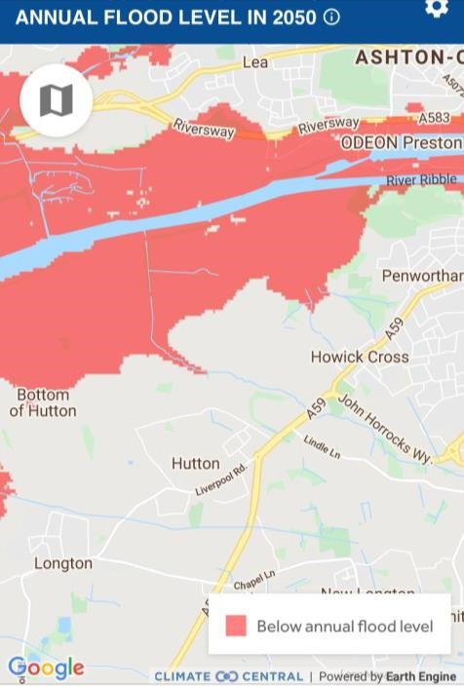

Mill Brook

Extract from Appendix 11.1 section 3.7.6

“The use of dry clay soil parameters may underestimate flood levels for some flood events with more saturated antecedent conditions, however it is not possible to account for all antecedent conditions. It is considered suitable to assume dry antecedent conditions for design simulations.”

Bizarrely the authors have employed a dry clay soil as the basis for their model which appears to contradict the statement given in section 3.4.7 “Ground conditions across the site were noted to be very wet and were typical of a poorly drained soil.”

4. Responsibilities for Design and Maintenance of the Flood Management System.

The financial consequences of system failure through poor design or poor maintenance are significant. In none of the documents covering flooding and flood prevention is there any attempt to quantify the impact of system failure.

At this stage there appears to be a complex chain of third party contributors including
McCloy consulting, Lees Roxborough, LCC as Lead Local Flood Authority and Taylor Wimpey as developer. Each third party appears to incorporate a number of disclaimers into their reports. Responsibility for system failure appears deliberately opaque.

It is unclear who is financially accountable for errors and omissions should the design principles be proven to be flawed, as they appear to be.

The systems proposed require regular and thorough maintenance and it is not clear who will be directly accountable for maintenance errors and omissions and who will be responsible for the substantial costs.

5. Spoil Disposal.

It is assumed that the flood basin spoil some 20,000 tonnes will be employed to construct the raised bank to the South.

It is unclear how the spoil generated from the excavation of the attenuation basins and swale system to the west of the site will be managed. It is estimated that approximately 50,000 tonnes of impermeable boulder clay will need to be disposed of by transporting offsite or to other parts of the site.

If it is transported for use on site this implies that parts of the site will be raised significantly, increasing the flood risk for existing dwellings

This spoil volume is equivalent to 2,000 truck trips that will occur during construction. It is unclear how this problem will be managed, however the potential environmental impact will be significant

6. Sewage treatment and dispersal.

Although this review focusses on the management of surface water run-off from site it is worth also reflecting on another key element of development infrastructure seldom given sufficient consideration when planning applications of this nature are submitted. This relates to the adequate provision of sewage treatment for the development.

We estimate that the population increase associated with the committed developments in South Ribble will be in the region of 6,400 people. The majority of this population increase is likely to come from outside the South Ribble region.

For this planning application development the population of the site assuming 1100 dwellings is likely to be in the region of 3,600 people, again with the majority coming from outside the South Ribble region.

This is significant relative to the population of South Ribble measured as 110,527 in 2018.

The provider of the sewage treatment in the region is United Utilities. No doubt they will claim that there is adequate capacity to treat the arising sewage from the committed developments and this application in particular.

However it is worth reflecting on the fact that United Utilities is the Company that discharges the most sewage to rivers and the sea in England, having amassed a total of 726,450 hours of routine discharges of raw sewage in a total of 113,940 events during 2020.

The sewage treatment infrastructure in NW England is in a shocking state and is wholly inadequate for the intended purpose.

The committed developments in South Ribble and the current planning applications for the Lanes will significantly increase the volume and frequency of such environmentally damaging discharges as the current sewage treatment systems have insufficient capacity as evidenced by Unitied Utilities appalling record in 2020.

On the lack of adequate sewage treatment facilities alone, no new planning applications should be agreed until United Utilities can guarantee sufficient sewage treatment capacity in the region, as demonstrated by the absence of routine discharges to river and sea.

APPENDIX 3
LCC Education statutory consultee response to the Lanes planning application 07/2021/00886/ORM
We have been reviewing the email response from the LCC Schools Planning group dated 8th October 2021 and the accompanying Education Contribution Assessment dated 17th September 2021.
We have a number of queries relating to the demand for primary school places arising from committed developments in the vicinity of the proposed site, and from the two planning applications 07/2021/00886/ORM and 07/2021/00887/ORM.
We have similar concerns regarding Secondary and Pre-school education provision.
- Background information
The committed developments considered to impact the proposed development are listed below. They were used in the transport assessment completed by Vectos
Committed developments employed in the Vectos TA
ID | Name | Dwellings | Employment space m2
1 | Croston Road | 174 (350) | N/A
2 | Croston Road North | 400 | N/A
3 | Penwortham Mills | 385 | N/A
4 | Gas Works | 248 (281) | N/A
5 | Cuerden | 210 | 205,600
6 | Test track | 950 | 28,000

Q1 Can LCC please confirm which of the committed developments listed above have been employed to predict the demand for primary and schools in the proposed development catchment?
Q2 under the section “Pupil Yield” there is reference made to a “detailed research project carried out during 2012” through which pupil yield is calculated for a bedroom mix within a development. Could LCC please provide a copy of this research paper?
- Assessment of Primary School Pupil Yield
LCC state that as the developer has not provided bedroom numbers for the development LCC apply a pupil yield appropriate for a four bedroom development.
The yield data employed for the four bedroom case is given below and extracted from the Education Contribution Assessment document.
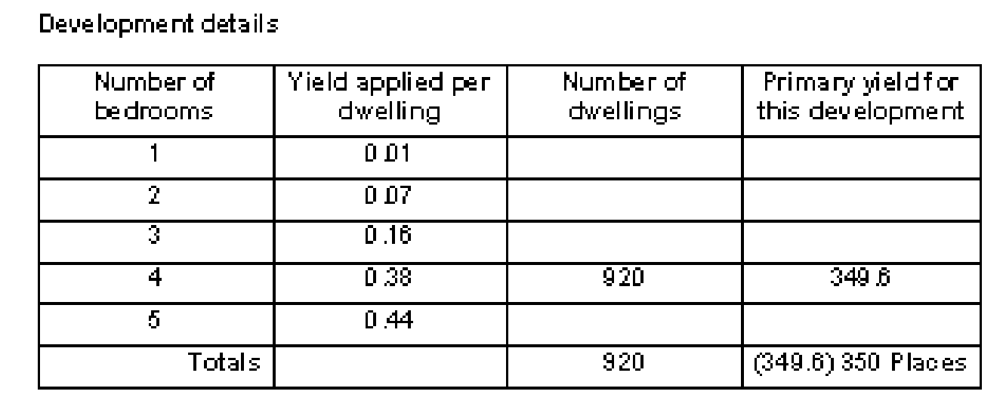
As part of our research on the subject of new development population demographics we have found a number of useful references including this one;
“Population Forecasting Study; Cognisant research for Northamptonshire County Council 2014.”
This was a comprehensive survey based research project with 2,985 addresses in new developments chosen at random using a mix of face to face interview and postal questionnaire to obtain the required information. The intent of the research was to establish robust Pupil Product Ratios (PPR’s) in order to yield accurate numbers of school age children generated by a new housing development.
As a result of that research data has been produced on how many school age children are resident in a new development dwelling as a function of bedroom number and also how the provision of social or affordable housing changes this metric.
Cognisant research study; Childen by age distribution as a function of bedroom number
Number of bedrooms in dwelling | 1 | 2 | 3 | 4
Pre School Children | 0 | 0.30 | 0.32 | 0.34
Primary School Children | 0 | 0.13 | 0.32 | 0.37
Secondary School Children | 0 | 0.03 | 0.17 | 0.22
Post 16’s | 0 | 0.03 | 0.07 | 0.09

Cognisant research study; Children by age distribution as a function of bedroom number for social housing
Number of bedrooms in dwelling | 1 | 2 | 3 | 4
Pre School Children | 0 | 0.52 | 0.63 | 0.92
Primary School Children | 0 | 0.19 | 0.83 | 0.58
Secondary School Children | 0 | 0.04 | 0.41 | 1.00
Post 16’s | 0 | 0.05 | 0.19 | 0.58

As LCC are aware the application includes for the provision of 30% affordable homes. Using a suitably weighted “yield” to account for affordable homes given in the Cognisant research the following adjusted yield is apparent. 0.7 x 0.38 + 0.3 x 0.58 = 0.44.
As LCC are aware the total number of homes from the two planning applications is 1,100.
Therefore the total yield of primary school children accounting for the provision of 30% affordable housing and assumption of 100% four bedroom homes is 484 not 350.
It should also be noted that from the Cognisant research the maximum “yield” of primary school children actually occurs in three bedroom homes. The assertion made in the LCC response that the choice of four bedrooms for the analysis presents a worst case scenario is not true according to the Cognisant research.
In fact if a more realistic assumption of 10 % two bedroom, 50% three bedroom and 40% four bedroom split is made for the development, the population of primary school children for the 1100 home Lanes development increases to 523. This is significantly higher that the estimate made in your response.
Q3 In the light of our findings are LCC prepared to reconsider the response that appears to seriously underestimate primary school demand from the development by neglecting the impact of affordable housing.
• Dependent Development; Impact on primary School places
Your response identifies 26 primary school places taken by dependent developments. We are concerned that many of the primary schools listed in the response are in fact closer to a large 600+ home committed development being built off Flensburg Way/Croston Road and to a committed housing development at Penwortham Mills at 633 homes, than they are to the development site access road. It is also worth noting that the Test Track housing development at 950 homes is only located 2.5 miles from the proposed site entrance.
In addition there are many small committed housing developments, 127 in total, in the area of Hutton, Hoole, Longton, New Longton and Howick parishes that will also be competing for primary school places. They do not appear to feature in the list of approved or pending housing developments given in the response The committted developments are identified in the SRBC Housing Position Statement 2020.
These committed developments provide the potential for (600 + 633 +127) x 0.38 primary school children = 517.
Of the fifteen listed primary schools at least five are closer to large committed developments than to the development site so to take a prudent position this dependent development demand is reduced to one third eg 172 primary places
It is difficult to reconcile your figure of 26 primary places from dependent developments with the figure of 172 calculated above.
Q4 Given the demand for primary school places from committed developments in the catchment area of many of the primary schools listed, are LCC prepared to reconsider the response that appears to seriously underestimate primary school demand from committed developments?
- The impact of Population demographics in South Ribble and Preston.
In your response it is argued that population data from the region indicates that for many of the primary schools listed pupil numbers decline in 2026 relative to the current roll.
We are struggling to reconcile this assumption with recent housing market assessments such as “Central Lancashire Strategic Market Assessment” by GL Hearn dated September 2017 which concludes that the population of South Ribble and Preston will grow by 2.9% and 3.1% respectively between 2014 and 2034. The Central Lancashire Housing study by Iceni dated October 2019 also indicates that household growth in South Ribble will increase by 3.3% from 2019 to 2029.
Q5 Given this data from two recent housing studies based on regional demographics are LCC prepared to reconsider the response that appears to contradict the findings of these studies by significantly reducing pupil numbers for many primary schools listed from current to 2026?
- Conclusion
Our analysis indicates a serious shortfall in primary school places.
3985 places available as a result of school expansion
3698 roll number by assuming population of primary school children does not change (conservative)
Leaving a capacity of 287 places
Assume 172 primary places taken by local committed developments (conservative)
Leaves a total of 115 places available for the Lanes development
523 places required by the Lanes at 1100 homes and 30% affordable housing
Shortfall of 408 primary places.
This indicates that there may be a serious issue developing and we think this merits a thorough and comprehensive review, as the implications of getting this analysis wrong are profound.

